Erf number |  | Date built |  |  |  | Type of building
Style |  | Architectural period |  |  |  | Present NHRA protection
Address & GPS Co-ord |  | Alterations |  |  |  | Use
 |  |  |  |  |  | Zoning
Date of survey
Name of the building |  | General evaluation |  |  |  | Suggested grading
 |  |  |  |  |  |  |  | Date of photograph(s):
Description |  | History |  |  |  | Social history
Significance in terms of NHRA
 | Very significant |  | Significant | Some significance | No significance |  | Not assessed
Historical
Rarity
Aesthetical
Technological
Cultural
Social history
Slave history

Erf number |  | Date built |  |  |  | Type of building |  | 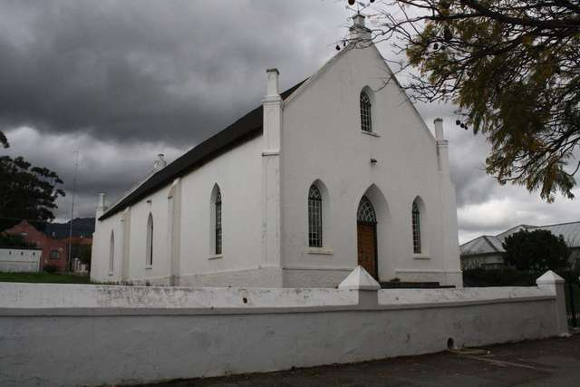
170 |  | 1845 |  |  |  | Institutional - Church
Style |  | Architectural period |  |  |  | Present NHRA protection
Cape Gothic Revival church |  | Cape Vernacular  (Cape Dutch) |  |  |  | Previous National Monument
Address & GPS Co. |  | Alterations |  |  |  | Use
34 Van der Stel Street  ( In front of Mission school) |  | The mission church was only slightly damaged in the earthquake and was bought by Tulbagh Municipality to be restored for use as a town hall. The modern corrugated iron roof was removed and a thatch one reinstated on the original roof timbers which were still in good condition |  |  |  | Community Hall
 |  |  |  |  |  | Zoning
Date of survey |  |  |  |  |  | Unspecified
9/09/2011
Name of the building |  | General evaluation |  |  |  | Suggested grading
Mission Church |  | Significant on many levels |  |  |  | Individually 2,  as collection 2
Description |  | History |  |  |  | Social history |  | Date of photograph(s): | 10 Sept 2012
Large specious thatch roof Hall Church in the Cape Gothic Revival style, features buttress and pinnacles. |  | Built for the newly emancipated slaves. Erf donated to the Rhenish Missionary Society in 1844. Mission Church was built across the road from the mission school in 1845. Building fulfilled the needs of the mass of recently emancipated slaves of the area. Built with donated funds and the labour of the good citizens of Tulbagh and freed converted salves. |  |  |  | Many slaves were baptized here, owing in part to a new law forbidding the sale of baptized slaves. Building stands to remind us of the inspiring work of Rev. Zahn and his parishioners who built this church for a mere 300 pounds |  | 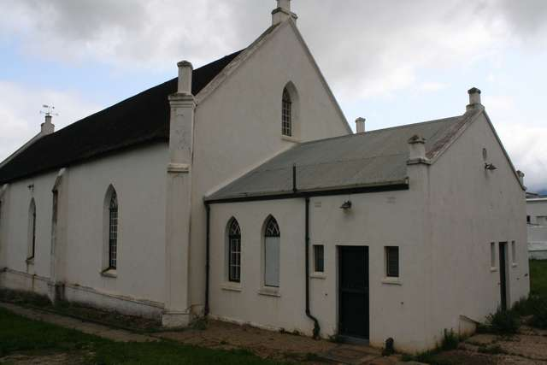
Significance in terms of NHRA
 | Very significant |  | Significant | Some significance | No significance |  | Not assessed
Historical |  |  | ✓
Rarity |  |  | ✓
Aesthetical |  |  | ✓
Technological |  |  |  | ✓
Cultural |  |  | ✓
Social history |  |  | ✓
Slave history | ✓

